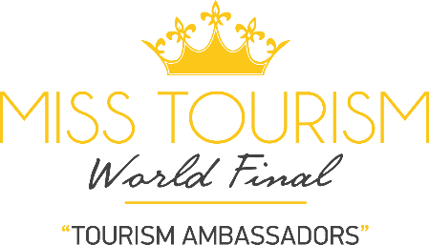

APPLY TO THE BEAUTY CONTEST

NAME OF COUNTRY REPRESENTED:
NAME SURNAME.
DATE OF BIRTH:

E-MAİL:
PHONE NY-UMBER:
PHONE NUMBER OF A NEARBY:

HAIR, SKIN, EYE COLOR:
HEIGHT, SIZE, WEIGHT:
BODY SIZES:

EDUCATIONAL STATUS:
YOUR JOB:
LANGUAGES YOU SPEAK:
ADRESS:

CAN YOU BRIEFLY TELL ABOUT YOURSELF:

You can make your application online on our website. You can send your photos from misstourism2021@gmail.com

