Contestants Personal Information
Please complete this part of the registration in full

Personal Information:

Nationality: |  |  | Gender: | Female / Male
Surname: |  |  | First Name:
Address: |  |  | Home Telephone:
 |  |  | Fax Telephone:
 |  |  | Mobile Telephone:
Town:
City: |  |  | Email Address:
Post Code:
Country: |  |  | Age:  Date Of Birth (D/M/Y):

Any foods you do not eat: |  |  | Are you vegetarian? | Yes / No
Do you smoke? | Yes / No |  | Do you have any allergies?
Blood Type:

Passport Number: |  |  | Date of Issue:
Issuing Authority: |  |  | Expiry Date:

Please provide a point of contact(s) in case of an emergency

Name: |  |  |  |  | Name:
Relationship:  i.e Mother/Father/Agent |  |  |  |  | Relationship:  i.e Mother/Father/Agent
Home Telephone: |  |  |  |  | Home Telephone:
Work Telephone: |  |  |  |  | Work Telephone:
Mobile Telephone: |  |  |  |  | Mobile Telephone:
Will anyone be travelling with you to the contest? If yes, please add details below: |  |  |  |  |  |  |  | Yes / No
Name:
Relationship:
i.e Mother/Father/Agent

Contestants Measurement Information
Please complete this part of the registration in full

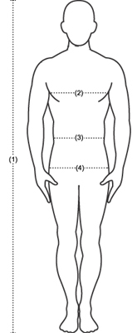 |  | Height: cm  Bust: cm  Waist: cm  Hips: cm  Weight: kg  Please highlight the appropriate selection  Dress Size: 6 / 8 / 10 / 12  Shoe Size: 37/ 38 / 39 /40 / 41 / 49  Eye Colour:  Hair Colour:

I authorise the use of my name, photographs, film footage and all images for use across all media including on television, the internet and also for any promotional use at the absolute discretion of Miss Tourism Organisation.

Delegates Signature: ...………………………………………….

Print Name: ................................................................................

Witnessed By:

Signed: ................................................................................

Print Name: ........................................................................

Address: ..............................................................................................................................................

