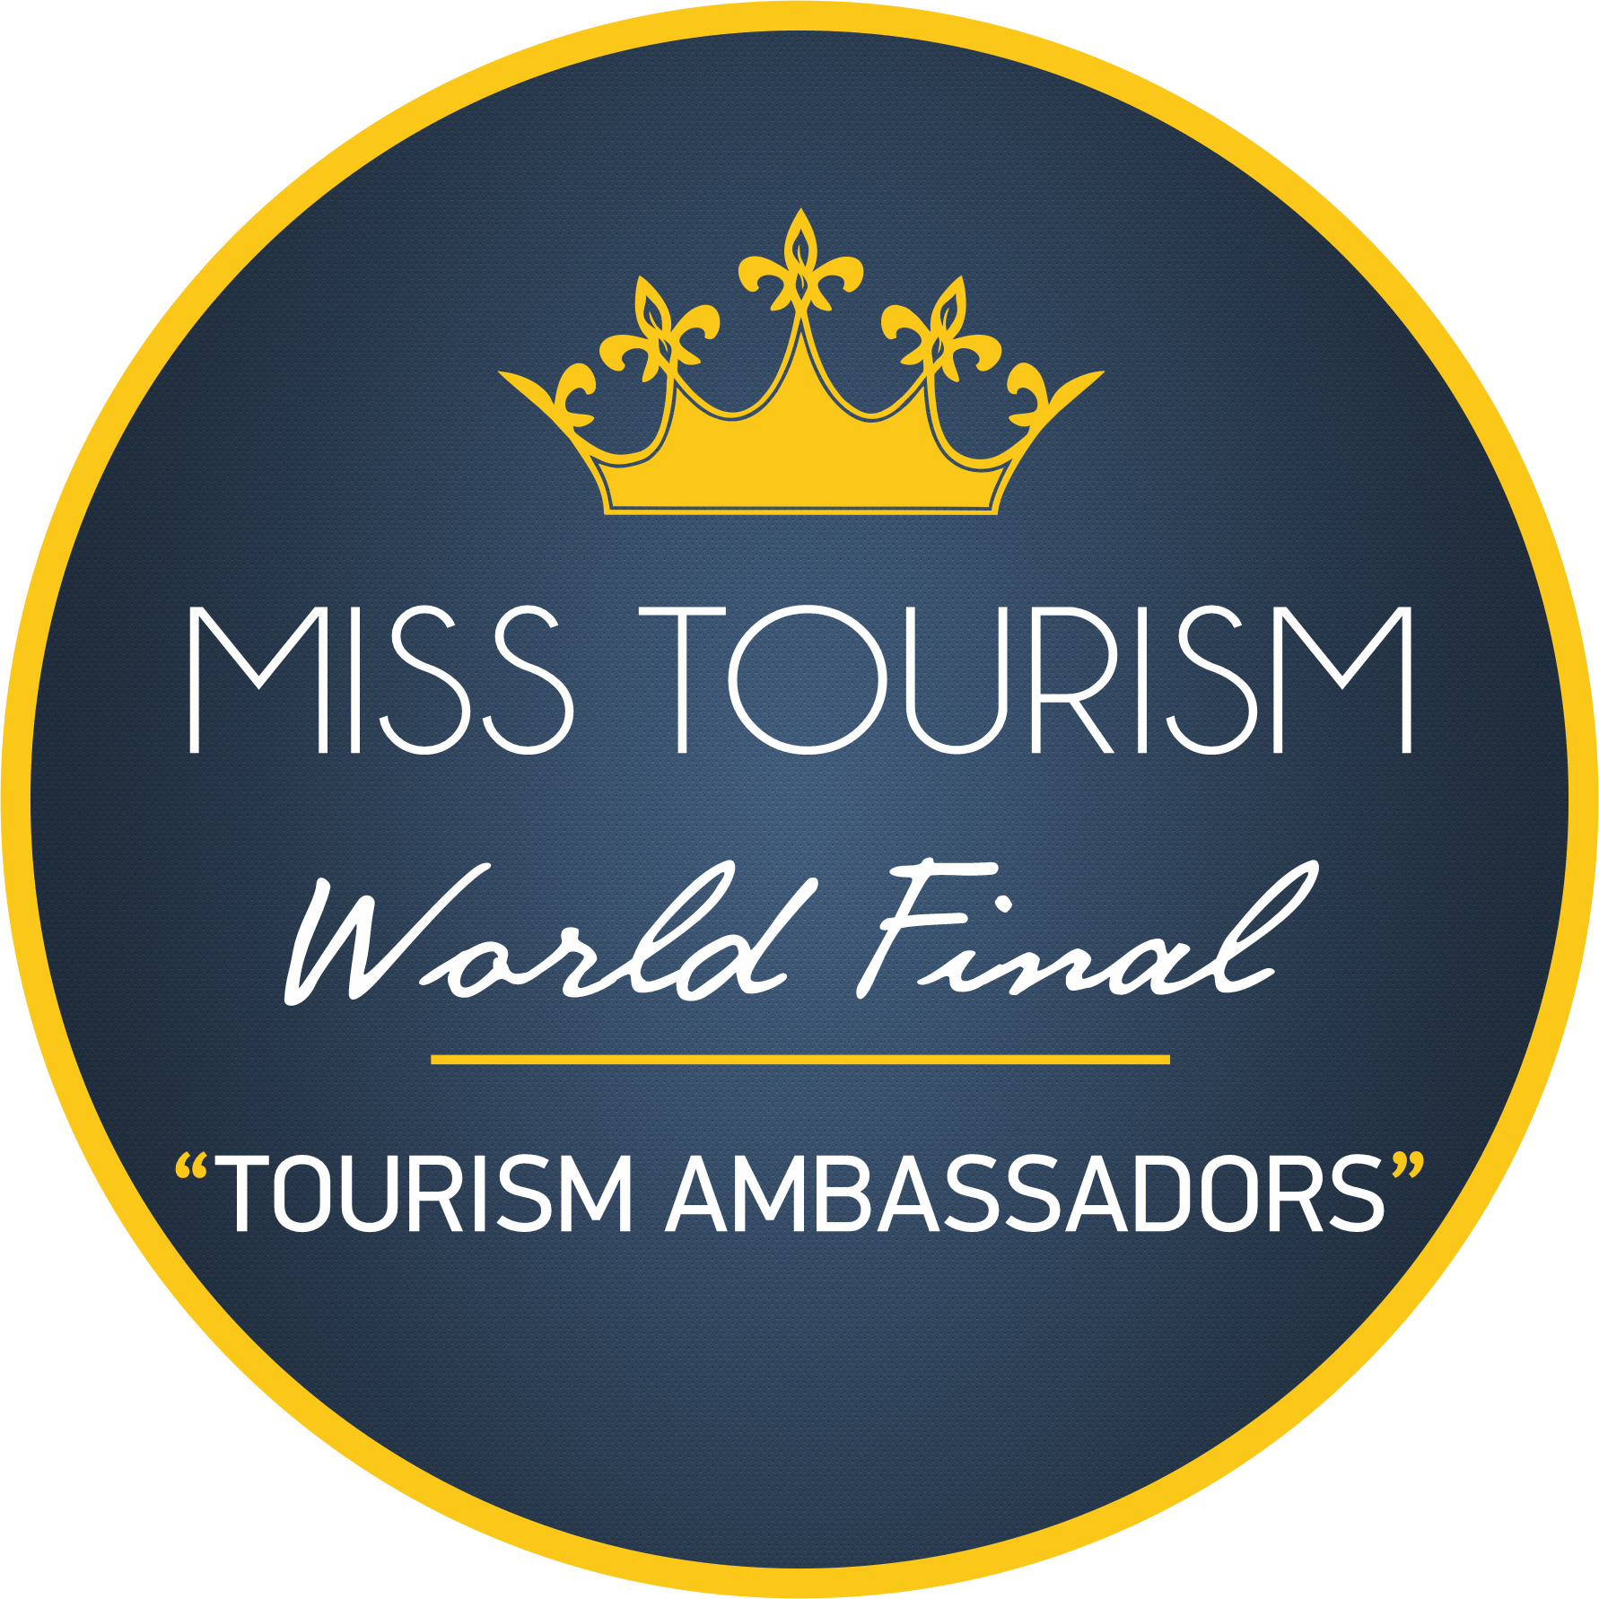 |  | MISS TOURISM  WORLD FINAL 2021 PROGRAM  7 MAY: ENTRANCE TO ISTANBUL HOTEL  8 MAY: PRESS CONFERENCE / BOSPHORUS TOUR / DINNER  9 MAY: SPONSOR AND ISTANBUL METROPOLITAN MUNICIPALITY VISIT / TOPKAPI MUSEUM VISIT / DINNER  10 MAY: ANKARA TRAVEL (PLANE) ENTRANCE TO THE HOTEL DINNER  11 MAY: ANKARA METROPOLITAN MUNICIPALITY VISIT / MINISTRY OF TOURISM VISIT / ANITKABİR VISIT / ATAKULE DINNER  12 MAY: SPONSOR VISIT / LUNCH / CAPPADOCIA BUS RIDE ENTRANCE TO THE HOTEL  13 MAY: BALLOON RIDE / LUNCH / VISITING FAIRY CHIMNEYS / DINNER  14 MAY: DEPARTURE TO ANKARA / TRAVEL TO BODRUM (PLANE) ENTRANCE TO THE HOTEL  15 MAY: BODRUM CASTLE VISIT / LUNCH / VISIT TO BODRUM MUNICIPALITY  16 MAY: TRAVEL TO ANTALYA (BUS) / ACCESS TO THE HOTEL  17 MAY: HOTEL AND SQUARE STUDIES  18 MAY: ASPENDOS TRIP / SIDE TRIP / MANAVGAT MUNICIPALITY VISIT / DINNER  19 MAY: HOTEL SQUAREOGRAPHY STUDIES AND PROVISIONS  20 MAY: DEMRE TRIP / LUNCH / HOTEL SQUARE STUDIES AND PROVIDES  21 MAY: KONYAALTI MUNICIPALITY / MURATPAŞA MUNICIPALITY / ANTALYA METROPOLITAN MUNICIPALITY VISIT / DINNER  22 MAY: HOTEL SQUAREOGRAPHY STUDIES AND PROVISIONS  23 MAY: FINAL

MISS TOURISM
INFORMATION

CONTACKT
TELEPHONE:
+90 532 177 84 36

WEBSITE:
www.misstourism.net

E-MAIL:
info@misstourism.net

