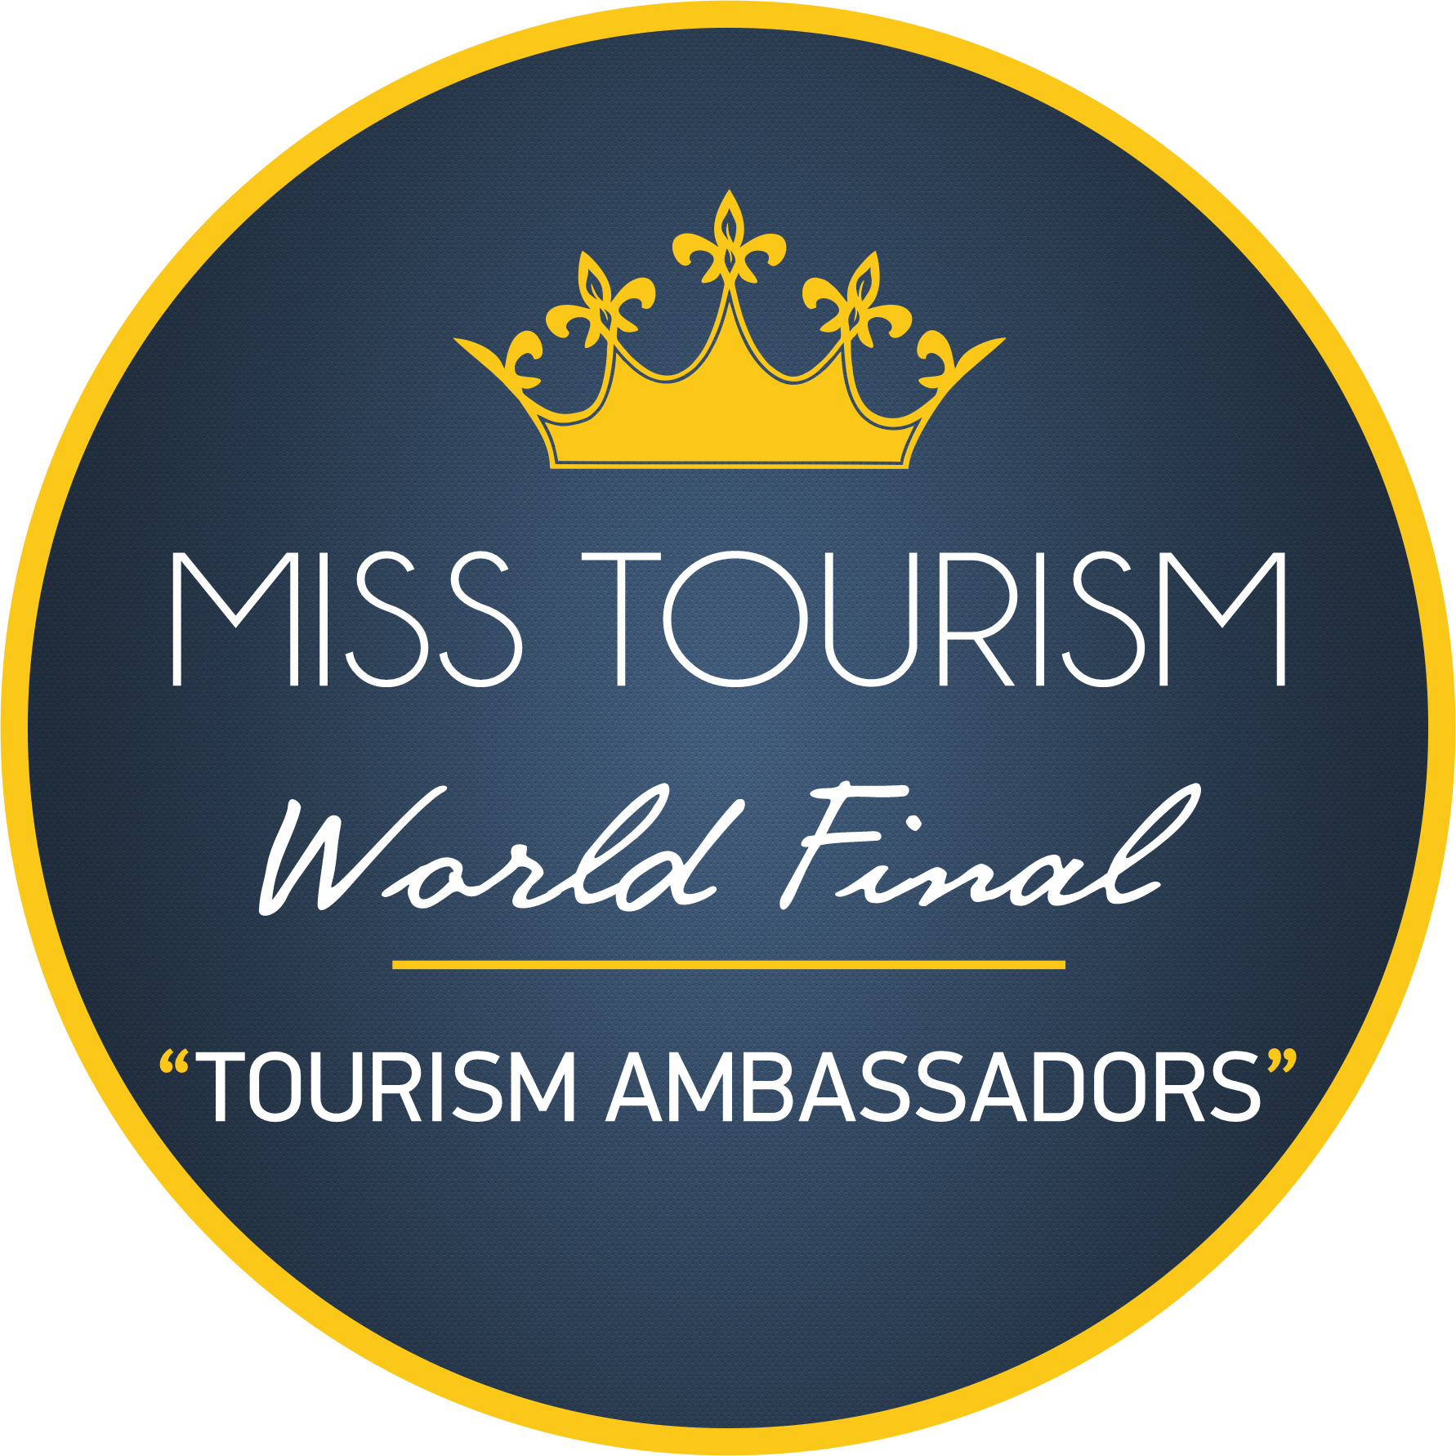 |  | MISS TOURISM  WORLD FINAL 2021  Miss Tourism beauty contest, which we have held for more than 20 years, has undertaken an important mission with its contribution to the tourism, culture and art promotion of the country where the organization takes place.  Apart from the beauties participating in the organization, it provides a unique advertisement and promotion opportunity during the camp, both for the organization and for the promotion of the country where the organization takes place and the sponsors by acting in partnership with the press members of the media organizations from their countries.  This organization, in which the beauties of the participating countries carry their own cultures, makes an important contribution to the world cultural heritage.  This organization, in which the contestants carry sections of the language, clothes and art they speak, really bears the most important element of its difference from similar organizations.  We are waiting for you and your contestant beauty to represent your country in this magnificent organization.  Let us know your participation from our application page on our website.  Required correspondence for other details will be made through your e-mail address.  Thank you.  Kind regards  Merve Çelik  Director of Information Services and Administration  Head Office  Miss Tourism

MISS TOURISM
INFORMATION

CONTACKT
TELEPHONE:
+90 532 177 84 36

WEBSITE:
www.misstourism.net

E-MAIL:
info@misstourism.net

